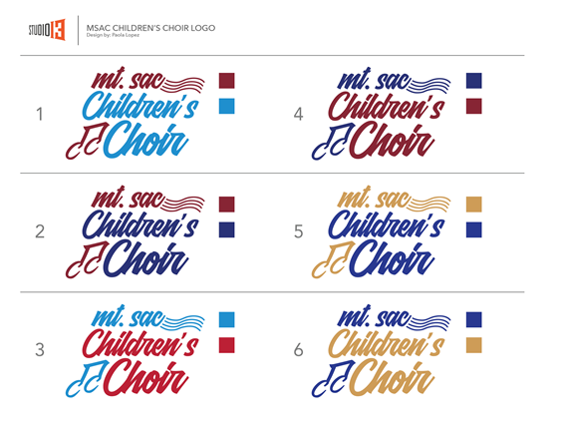

**Mt. SAC Children’s Choir Contract**

Fall 2019 / Spring 2020

**Mission -** *Transforming the lives of children and youth through excellence in music education and choral singing.*

**Vision Statement: -** *To foster life-long values, including the love of music; the pursuit of excellence; self-discipline and teamwork; self-expression and self-confidence; and a greater understanding of oneself, the world, and its people.*

**Goals -** Reach a high level of artistic excellence in choral music performance.

Provide an opportunity to produce, practice and perform treble repertoire of many different styles.

Achieve music literacy through sequential music activities.

Foster personal and musical growth of singers.

Enrich the lives of children from diverse ethnic and socio-economic backgrounds in the Mt. SAC area.

**Schedule & Attendance** - Rehearsals are Tuesday afternoons/evenings (Dolce Choir from 4:15 – 5:15, Cantabile Singers from 5:30 – 6:45 and Mt. SAC Youth Chorale from 6:30 – 8:15). Students must be on time. Students are expected to commit to the entire season (September - June). If a student misses more than three rehearsals in a semester, he/she may be asked to leave the ensemble for the remainder of the semester.

**Respecting Mt. SAC Property** –Mt. San Antonio College is incredibly generous to provide such high-demand space for the Mt. SAC Children’s Choir. Therefore, it is imperative that we are respectful to the facility and its workers. No food or beverage is allowed in the rehearsal rooms or the theater by students or adults. Students are to walk, not run, throughout the facility. Students are not allowed to touch any equipment or instruments without the permission of a staff member. Restrooms are provided for all MSACCC families in the courtyard area. Please keep them neat. We are guests who want to be invited back for future semesters to come.

**Rules and Expectations**

1. RESPECT. (Each other, the staff, the music, the space, yourself, etc.)
2. Sit or stand with good posture when singing.
3. Do not call out. Raise your hand until you are called on.
4. No cell phones
5. Wear your name tag.
6. Try your best & have fun!

*Parents and guardians, thank you for support. Your child and the students in the ensemble will have a more productive, safe, educational, and fun experience when all rules and expectations are understood and followed through. Please sign and return this form to the MSACCC Administrative Assistant.*

Student Name: Student Signature:

I, ______________________ Parent/Guardian of the above child, have read and reviewed the contract with my child and will support them in understanding the rules & expectations and the consequences of their behavior in not abiding to the contract.

Printed Name: Signature: