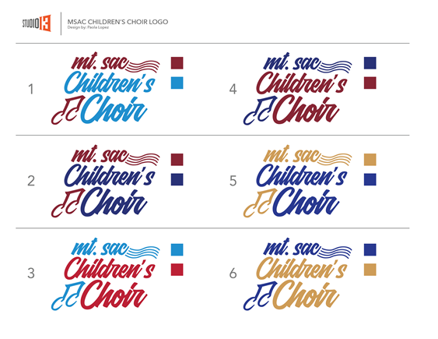 Leave of Absence

Dated this _________________________ day of ____________________, this document serves

as an agreement between ________________________ and ____________________________.
singer name director

______________________ has requested a leave of absence from ______________________ .
singer name choir

for the following dates in order to participate in _____________________________________ .
activity

_________________________ grants this leave of absence beginning ____________________ .
director

and ending ___________________________, with the condition that:

(List any conditions for the leave of absence.)

- ________________________________________________________________________________

- ________________________________________________________________________________

- ________________________________________________________________________________

This Leave of absence in no way affects the financial obligation of the singer. All tuition and fees are due as stated in the financial contract.

_____________________________________________________________________________________
Singer Signature

_____________________________________________________________________________________
Parent Signature

_____________________________________________________________________________________
Director Signature

Original to Administrative Assistant
Copy to: _____ Choir Coordinator
_____ Director

