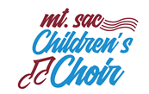Non-Returning Singer Form

______________________________________________________________________________

Today’s Date: _____/_____/_____

Singer Name: _________________________________ ______________________________
(First) (Last)

Present Choir: _________________________________ Present Grade: ______________

Thank you for my MSACCC experiences during the 2019-2020 season. I have chosen not to re-audition for next season because:

______________________________________________________________________________

______________________________________________________________________________

_____________________________________ ____________________________________
Singer’s Signature Parent Signature

