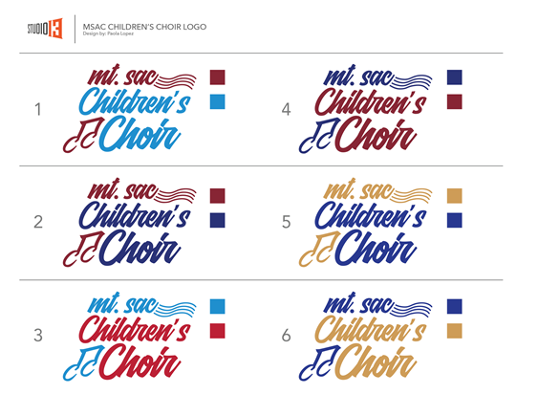

**Mt. SAC Children’s Choir Student Volunteer Form**

Name: _____________________________________ Student #___________________________

Cell Phone:___________________________ Email:___________________________________

Choir Preference: ___ Dolce Choir (grades 1-3) ___ Cantabile Singers (grades 3-6)

___ Mt. SAC Youth Chorale (grades 7-10) ___ Any of the Choirs

Availability on Tuesdays: _________________________________________________________

List your current major: __________________________________________________________

Leadership Experience: __________________________________________________________

________________________________________________________________________

Experience Working with Children: _________________________________________________

________________________________________________________________________

Reasons you want to volunteer: ___________________________________________________

________________________________________________________________________